VLSI DESIGN AND AUTOMATION SUMMER INTERNSHIP
WEEK 4 SUBMISSION
RESOURCE: WEEK 6 (ENC,NETLIST and DATA files are here)
VERILOG CODE AND WAVE FORM

VERILOG CODE :
`timescale 1ns / 1ps
module digital_safe (
input clk,
input rst,
input [31:0] entered_code,
input [31:0] master_code,
input [31:0] duress_code,
input reset_code_button,
input [31:0] new_code,
input confirm_reset,
output reg unlocked,
output reg alert
);

reg [1:0] attempts;
reg [31:0] current_code;
reg locked;
reg [19:0] lock_timer;

localparam MAX_ATTEMPTS = 2'd3;
localparam LOCK_TIME = 20'd15_000_000; // Adjust as per clock frequency (e.g., ~5 min for 50MHz)

always @(posedge clk or posedge rst) begin
if (rst) begin
current_code <= 32'h12345678;
attempts <= 0;
locked <= 0;
lock_timer <= 0;
unlocked <= 0;
alert <= 0;
end else begin
if (locked) begin
if (lock_timer > 0)
lock_timer <= lock_timer - 1;
else begin
locked <= 0;
attempts <= 0;
end
end else if (reset_code_button && confirm_reset) begin
current_code <= new_code;
end else begin
if (entered_code == current_code || entered_code == master_code) begin
unlocked <= 1;
alert <= 0;
attempts <= 0;
end else if (entered_code == duress_code) begin
unlocked <= 1;
alert <= 1;
attempts <= 0;
end else begin
attempts <= attempts + 1;
if (attempts == MAX_ATTEMPTS - 1) begin
locked <= 1;
lock_timer <= LOCK_TIME;
unlocked <= 0;
alert <= 0;
end
end
end
end
end

endmodule

TEST BENCH CODE :
`timescale 1ns / 1ps

module tb_digital_safe;

reg clk;
reg rst;
reg [31:0] entered_code;
reg [31:0] master_code;
reg [31:0] duress_code;
reg reset_code_button;
reg [31:0] new_code;
reg confirm_reset;
wire unlocked;
wire alert;

digital_safe uut (
.clk(clk),
.rst(rst),
.entered_code(entered_code),
.master_code(master_code),
.duress_code(duress_code),
.reset_code_button(reset_code_button),
.new_code(new_code),
.confirm_reset(confirm_reset),
.unlocked(unlocked),
.alert(alert)
);

// Clock Generation
initial begin
clk = 0;
forever #10 clk = ~clk; // 50 MHz clock
end

initial begin
// Initialize Inputs
rst = 1;
entered_code = 32'h0;
master_code = 32'h87654321;
duress_code = 32'h11112222;
reset_code_button = 0;
new_code = 32'hAABBCCDD;
confirm_reset = 0;

#50;
rst = 0;

// Test correct code
#20;
entered_code = 32'h12345678;
#20;

// Test incorrect attempts
entered_code = 32'hDEADBEEF; #20;
entered_code = 32'hCAFEBABE; #20;
entered_code = 32'hBAD0C0DE; #20;

// Wait for lock
#100;

// Test master code unlock
entered_code = 32'h87654321; #20;

// Reset password
reset_code_button = 1;
confirm_reset = 1;
#20;
reset_code_button = 0;
confirm_reset = 0;

// Test with new code
entered_code = 32'hAABBCCDD; #20;

// Test duress code
entered_code = 32'h11112222; #20;

#100;
$stop;
end

endmodule

WAVE FORM :
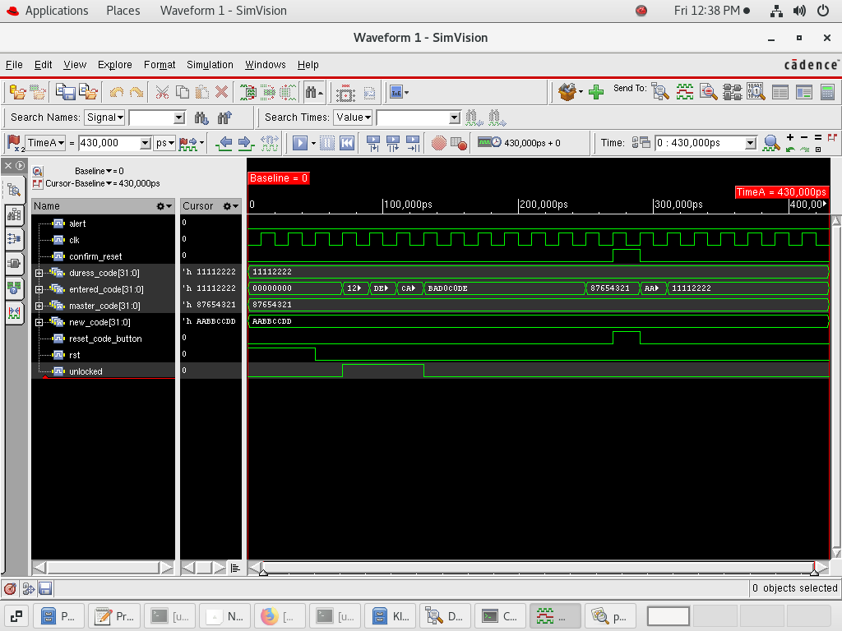

WEEK 2 :
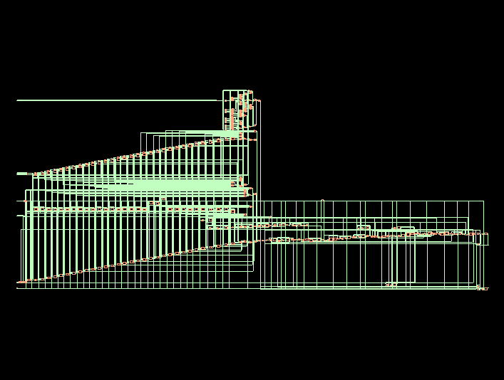

REPORT ( WEEK 2 ) :
legacy_genus:/> report power
Info : Joules engine is used. [RPT-16]
: Joules engine is being used for the command report_power.
Info : ACTP-0001 [ACTPInfo] Activity propagation started for stim#0 netlist
: digital_safe
Info : ACTP-0009 [ACTPInfo] Activity Propagation Progress Report : 100%
Info : ACTP-0001 Activity propagation ended for stim#0
Info : PWRA-0001 [PwrInfo] compute_power effective options
: -mode : vectorless
: -skip_propagation : 1
: -frequency_scaling_factor : 1.0
: -use_clock_freq : stim
: -stim :/stim#0
: -fromGenus : 1
Info : ACTP-0001 Timing initialization started
Info : ACTP-0001 Timing initialization ended
Info : PWRA-0002 [PwrInfo] Skipping activity propagation due to -skip_ap
: option....
Warning: PWRA-0302 [PwrWarn] Frequency scaling is not applicable for vectorless
: flow. Ignoring frequency scaling.
Warning: PWRA-0304 [PwrWarn] -stim option is not applicable with vectorless mode
: of power analysis, ignored this option.
Info : PWRA-0002 Started 'vectorless' power computation.
Info : PWRA-0009 [PwrInfo] Power Computation Progress Report : 100%
Info : PWRA-0002 Finished power computation.
Info : PWRA-0007 [PwrInfo] Completed successfully.
: Info=6, Warn=2, Error=0, Fatal=0
Instance: /digital_safe
Power Unit: W
PDB Frames: /stim#0/frame#0
-------------------------------------------------------------------------
Category Leakage Internal Switching Total Row%
-------------------------------------------------------------------------
memory 0.00000e+00 0.00000e+00 0.00000e+00 0.00000e+00 0.00%
register 1.01576e-07 2.60008e-05 2.46114e-06 2.85635e-05 33.88%
latch 0.00000e+00 0.00000e+00 0.00000e+00 0.00000e+00 0.00%
logic 1.57909e-07 3.48826e-05 2.07134e-05 5.57539e-05 66.12%
bbox 0.00000e+00 0.00000e+00 0.00000e+00 0.00000e+00 0.00%
clock 0.00000e+00 0.00000e+00 0.00000e+00 0.00000e+00 0.00%
pad 0.00000e+00 0.00000e+00 0.00000e+00 0.00000e+00 0.00%
pm 0.00000e+00 0.00000e+00 0.00000e+00 0.00000e+00 0.00%
-------------------------------------------------------------------------
Subtotal 2.59485e-07 6.08834e-05 2.31746e-05 8.43174e-05 100.00%
Percentage 0.31% 72.21% 27.48% 100.00% 100.00%
-----------------------------------------------------------------------
legacy_genus:/> report area
============================================================
Generated by: Genus(TM) Synthesis Solution 20.11-s111_1
Generated on: Jul 25 2025 12:44:06 pm
Module: digital_safe
Technology library: fast
Operating conditions: fast (balanced_tree)
Wireload mode: enclosed
Area mode: timing library
============================================================

Instance Module Cell Count Cell Area Net Area Total Area Wireload
------------------------------------------------------------------------------
digital_safe 329 0.000 0.000 0.000 <none> (D)
(D) = wireload is default in technology library

legacy_genus:/> report timing
============================================================
Generated by: Genus(TM) Synthesis Solution 20.11-s111_1
Generated on: Jul 25 2025 12:44:09 pm
Module: digital_safe
Technology library: fast
Operating conditions: fast (balanced_tree)
Wireload mode: enclosed
Area mode: timing library
============================================================

Pin Type Fanout Load Slew Delay Arrival
(fF) (ps) (ps) (ps)
-----------------------------------------------------------------------------------
current_code_reg[1]/CK 0 +0 0 R
current_code_reg[1]/QN SDFFRX4 1 2.5 13 +111 111 F
csa_tree_ADD_TC_OP16_groupi_g2187/B +0 111
csa_tree_ADD_TC_OP16_groupi_g2187/CO ADDFXL 1 2.0 37 +66 176 F
csa_tree_ADD_TC_OP16_groupi_g2186/CI +0 176
csa_tree_ADD_TC_OP16_groupi_g2186/CO ADDFXL 1 2.0 38 +67 243 F
csa_tree_ADD_TC_OP16_groupi_g2185/CI +0 243
csa_tree_ADD_TC_OP16_groupi_g2185/CO ADDFXL 1 2.0 38 +67 310 F
csa_tree_ADD_TC_OP16_groupi_g2184/CI +0 310
csa_tree_ADD_TC_OP16_groupi_g2184/CO ADDFXL 1 2.0 38 +67 377 F
csa_tree_ADD_TC_OP16_groupi_g2183/CI +0 377
csa_tree_ADD_TC_OP16_groupi_g2183/CO ADDFXL 1 2.0 38 +67 444 F
csa_tree_ADD_TC_OP16_groupi_g2182/CI +0 444
csa_tree_ADD_TC_OP16_groupi_g2182/CO ADDFXL 1 2.0 38 +67 511 F
csa_tree_ADD_TC_OP16_groupi_g2181/CI +0 511
csa_tree_ADD_TC_OP16_groupi_g2181/CO ADDFXL 1 2.0 38 +67 578 F
csa_tree_ADD_TC_OP16_groupi_g2180/CI +0 578
csa_tree_ADD_TC_OP16_groupi_g2180/CO ADDFXL 1 2.0 38 +67 644 F
csa_tree_ADD_TC_OP16_groupi_g2179/CI +0 644
csa_tree_ADD_TC_OP16_groupi_g2179/CO ADDFXL 1 2.0 38 +67 711 F
csa_tree_ADD_TC_OP16_groupi_g2178/CI +0 711
csa_tree_ADD_TC_OP16_groupi_g2178/CO ADDFXL 1 2.0 38 +67 778 F
csa_tree_ADD_TC_OP16_groupi_g2177/CI +0 778
csa_tree_ADD_TC_OP16_groupi_g2177/CO ADDFXL 1 2.0 38 +67 845 F
csa_tree_ADD_TC_OP16_groupi_g2176/CI +0 845
csa_tree_ADD_TC_OP16_groupi_g2176/CO ADDFXL 1 2.0 38 +67 912 F
csa_tree_ADD_TC_OP16_groupi_g2175/CI +0 912
csa_tree_ADD_TC_OP16_groupi_g2175/CO ADDFXL 1 2.0 38 +67 979 F
csa_tree_ADD_TC_OP16_groupi_g2174/CI +0 979
csa_tree_ADD_TC_OP16_groupi_g2174/CO ADDFXL 1 2.0 38 +67 1046 F
csa_tree_ADD_TC_OP16_groupi_g2173/CI +0 1046
csa_tree_ADD_TC_OP16_groupi_g2173/CO ADDFXL 1 2.0 38 +67 1113 F
csa_tree_ADD_TC_OP16_groupi_g2172/CI +0 1113
csa_tree_ADD_TC_OP16_groupi_g2172/CO ADDFXL 1 2.0 38 +67 1180 F
csa_tree_ADD_TC_OP16_groupi_g2171/CI +0 1180
csa_tree_ADD_TC_OP16_groupi_g2171/CO ADDFXL 1 2.0 38 +67 1246 F
csa_tree_ADD_TC_OP16_groupi_g2170/CI +0 1246
csa_tree_ADD_TC_OP16_groupi_g2170/CO ADDFXL 1 2.0 38 +67 1313 F
csa_tree_ADD_TC_OP16_groupi_g2169/CI +0 1313
csa_tree_ADD_TC_OP16_groupi_g2169/CO ADDFXL 1 2.0 38 +67 1380 F
csa_tree_ADD_TC_OP16_groupi_g2168/CI +0 1380
csa_tree_ADD_TC_OP16_groupi_g2168/CO ADDFXL 1 2.0 38 +67 1447 F
csa_tree_ADD_TC_OP16_groupi_g2167/CI +0 1447
csa_tree_ADD_TC_OP16_groupi_g2167/CO ADDFXL 1 2.0 38 +67 1514 F
csa_tree_ADD_TC_OP16_groupi_g2166/CI +0 1514
csa_tree_ADD_TC_OP16_groupi_g2166/CO ADDFXL 1 2.0 38 +67 1581 F
csa_tree_ADD_TC_OP16_groupi_g2165/CI +0 1581
csa_tree_ADD_TC_OP16_groupi_g2165/CO ADDFXL 1 2.0 38 +67 1648 F
csa_tree_ADD_TC_OP16_groupi_g2164/CI +0 1648
csa_tree_ADD_TC_OP16_groupi_g2164/CO ADDFXL 1 2.0 38 +67 1715 F
csa_tree_ADD_TC_OP16_groupi_g2163/CI +0 1715
csa_tree_ADD_TC_OP16_groupi_g2163/CO ADDFXL 1 2.0 38 +67 1782 F
csa_tree_ADD_TC_OP16_groupi_g2162/CI +0 1782
csa_tree_ADD_TC_OP16_groupi_g2162/CO ADDFXL 1 2.0 38 +67 1849 F
csa_tree_ADD_TC_OP16_groupi_g2161/CI +0 1849
csa_tree_ADD_TC_OP16_groupi_g2161/CO ADDFXL 1 2.0 38 +67 1916 F
csa_tree_ADD_TC_OP16_groupi_g2160/CI +0 1916
csa_tree_ADD_TC_OP16_groupi_g2160/CO ADDFXL 1 2.0 38 +67 1982 F
csa_tree_ADD_TC_OP16_groupi_g2159/CI +0 1982
csa_tree_ADD_TC_OP16_groupi_g2159/CO ADDFXL 1 2.0 38 +67 2049 F
csa_tree_ADD_TC_OP16_groupi_g2158/CI +0 2049
csa_tree_ADD_TC_OP16_groupi_g2158/CO ADDFXL 1 1.5 33 +64 2114 F
csa_tree_ADD_TC_OP16_groupi_g2/C +0 2114
csa_tree_ADD_TC_OP16_groupi_g2/Y XNOR3XL 1 0.9 28 +47 2161 R
g5348/D +0 2161
g5348/Y NAND4X1 1 0.9 54 +32 2192 F
g5497/AN +0 2192
g5497/Y NAND4BBX4 1 3.3 58 +70 2262 F
g5356/D +0 2262
g5356/Y NOR4BBX4 1 0.7 50 +26 2288 R
g5178/B1 +0 2288
g5178/Y AO22X1 2 1.2 20 +45 2332 R
g5174/B +0 2332
g5174/Y OR2X1 3 1.9 18 +26 2358 R
g5173/B +0 2358
g5173/Y OR2X1 3 2.2 20 +26 2384 R
g5168/B +0 2384
g5168/Y OR2X1 4 3.8 31 +32 2416 R
g5166/A +0 2416
g5166/Y CLKINVX2 5 3.9 19 +17 2433 F
g5143/B +0 2433
g5143/Y OR2X1 2 2.4 24 +39 2472 F
g5139/A +0 2472
g5139/Y CLKINVX2 11 7.0 28 +20 2491 R
g5132/B0 +0 2491
g5132/Y AO21X2 2 1.2 17 +31 2522 R
g5113/A1 +0 2522
g5113/Y AO21X2 1 0.8 16 +44 2566 R
lock_timer_reg[16]/D DFFRHQX8 +0 2566
lock_timer_reg[16]/CK setup 0 +35 2602 R
-----------------------------------------------------------------------------------
Timing slack : UNCONSTRAINED
Start-point : current_code_reg[1]/CK
End-point : lock_timer_reg[16]/D

WEEK 3 & WEEK 4 :
FLOOR PLACEMENT , POWER PLANNING , ROUTING , CTS
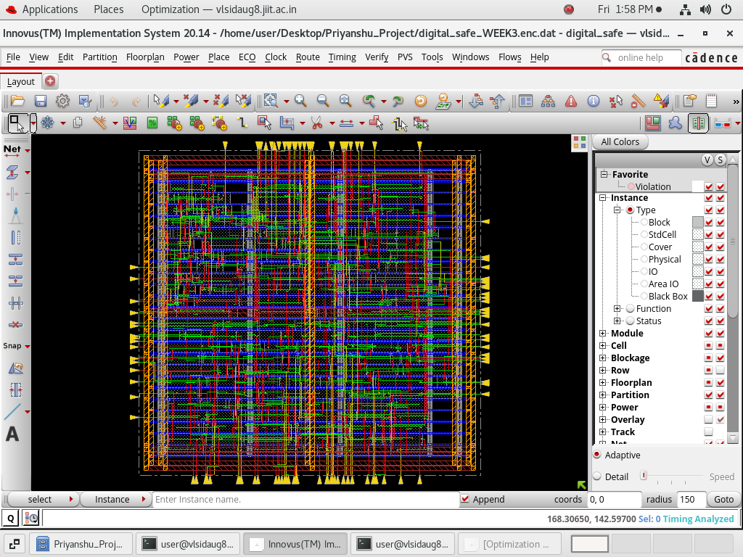
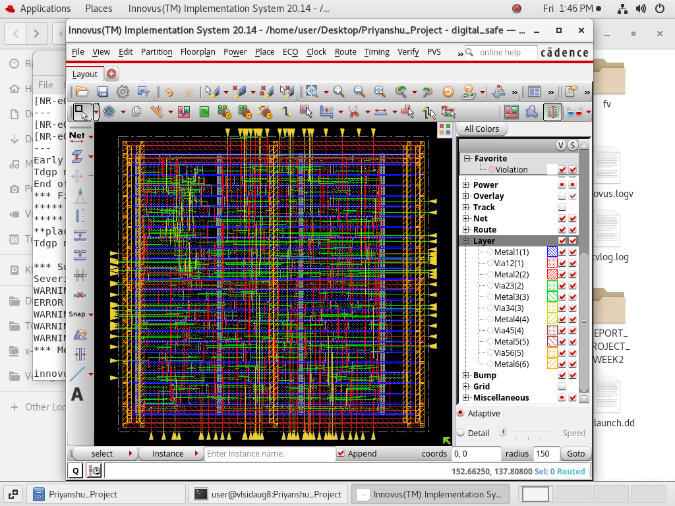
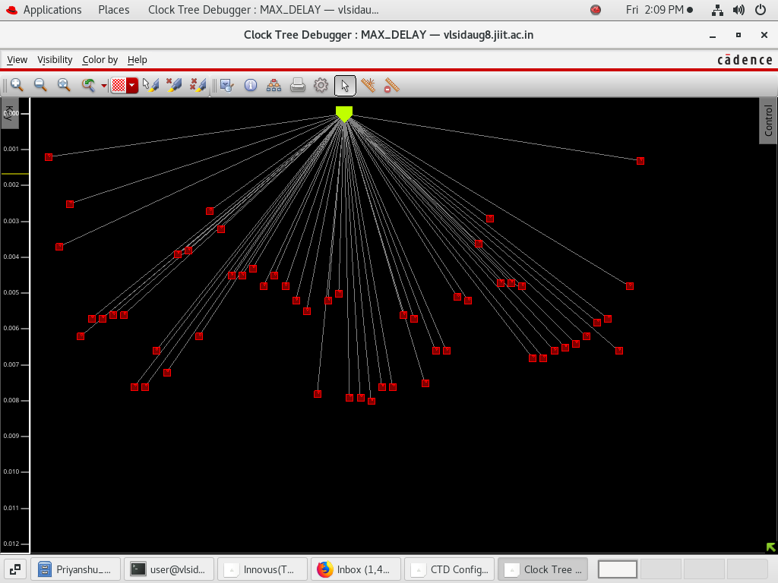

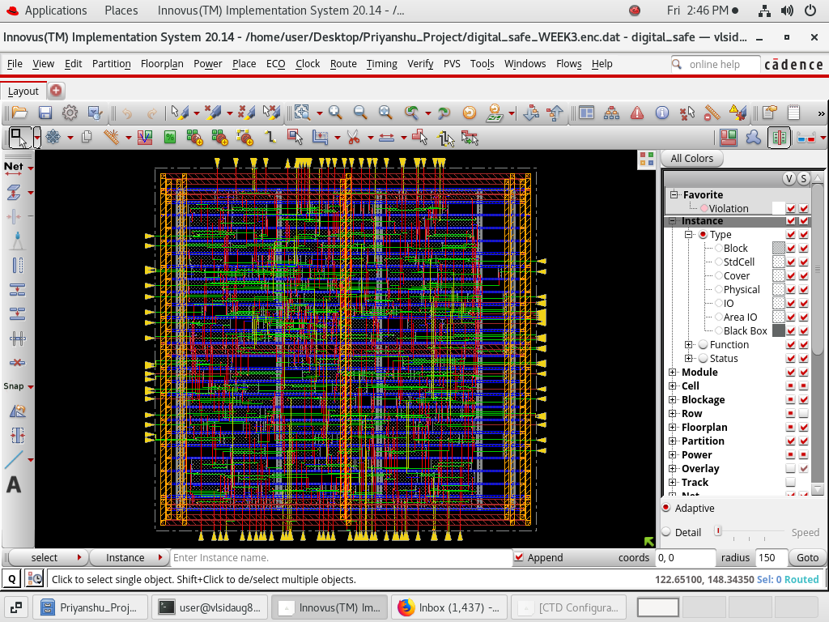
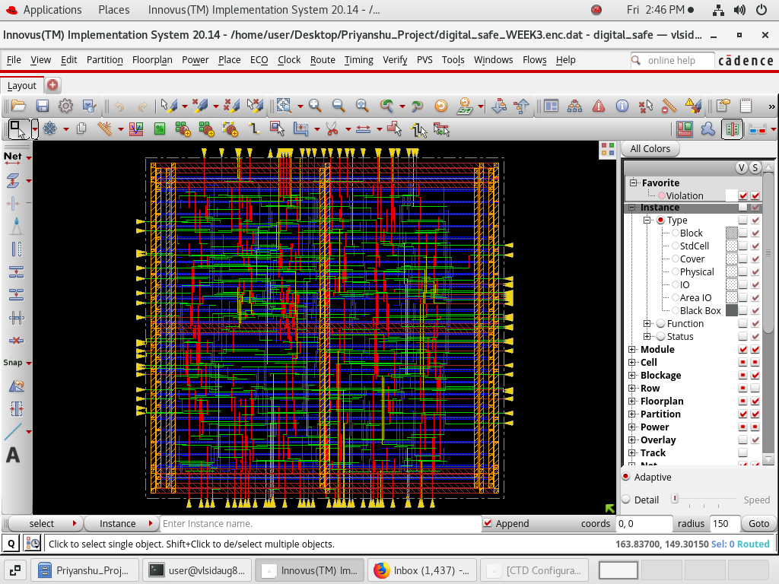

REPORT ( WEEK 4 ) :

------------------------------------------------------------------
timeDesign Summary
------------------------------------------------------------------

Setup views included:
WORST

+--------------------+---------+---------+---------+
| Setup mode | all | reg2reg | default |
+--------------------+---------+---------+---------+
| WNS (ns):| 0.000 | N/A | 0.000 |
| TNS (ns):| 0.000 | N/A | 0.000 |
| Violating Paths:| 0 | N/A | 0 |
| All Paths:| 0 | N/A | 0 |
+--------------------+---------+---------+---------+

+----------------+-------------------------------+------------------+
| | Real | Total |
| DRVs +------------------+------------+------------------|
| | Nr nets(terms) | Worst Vio | Nr nets(terms) |
+----------------+------------------+------------+------------------+
| max_cap | 1 (1) | -0.149 | 1 (1) |
| max_tran | 0 (0) | 0.000 | 0 (0) |
| max_fanout | 0 (0) | 0 | 0 (0) |
| max_length | 0 (0) | 0 | 0 (0) |
+----------------+------------------+------------+------------------+

Density: 84.653%
Routing Overflow: 0.00% H and 0.34% V
------------------------------------------------------------------
Reported timing to dir timingReports
Total CPU time: 0.16 sec
Total Real time: 0.0 sec
Total Memory Usage: 1469.136719 Mbytes
*** timeDesign #1 [finish] : cpu/real = 0:00:00.1/0:00:00.6 (0.3), totSession cpu/real = 0:00:17.8/0:01:20.6 (0.2), mem = 1469.1M
innovus 1>

innovus 1> report_power

Power Net Detected:
Voltage Name
0V VSS
0.9V VDD
Using Power View: WORST.
Set Default Frequency 100MHz.

Begin Power Analysis

0V VSS
0.9V VDD

Begin Processing Timing Library for Power Calculation

Begin Processing Timing Library for Power Calculation

Begin Processing Power Net/Grid for Power Calculation

Ended Processing Power Net/Grid for Power Calculation: (cpu=0:00:00, real=0:00:00, mem(process/total/peak)=1083.79MB/2621.09MB/1083.82MB)

Begin Processing Timing Window Data for Power Calculation

Ended Processing Timing Window Data for Power Calculation: (cpu=0:00:00, real=0:00:00, mem(process/total/peak)=1083.91MB/2621.09MB/1083.91MB)

Begin Processing User Attributes

Ended Processing User Attributes: (cpu=0:00:00, real=0:00:00, mem(process/total/peak)=1083.97MB/2621.09MB/1083.97MB)

Begin Processing Signal Activity

Starting Levelizing
2025-Jul-25 13:56:14 (2025-Jul-25 08:26:14 GMT)
2025-Jul-25 13:56:14 (2025-Jul-25 08:26:14 GMT): 10%
2025-Jul-25 13:56:14 (2025-Jul-25 08:26:14 GMT): 20%
2025-Jul-25 13:56:14 (2025-Jul-25 08:26:14 GMT): 30%
2025-Jul-25 13:56:14 (2025-Jul-25 08:26:14 GMT): 40%
2025-Jul-25 13:56:14 (2025-Jul-25 08:26:14 GMT): 50%
2025-Jul-25 13:56:14 (2025-Jul-25 08:26:14 GMT): 60%
2025-Jul-25 13:56:14 (2025-Jul-25 08:26:14 GMT): 70%
2025-Jul-25 13:56:14 (2025-Jul-25 08:26:14 GMT): 80%
2025-Jul-25 13:56:14 (2025-Jul-25 08:26:14 GMT): 90%

Finished Levelizing
2025-Jul-25 13:56:14 (2025-Jul-25 08:26:14 GMT)

Starting Activity Propagation
2025-Jul-25 13:56:14 (2025-Jul-25 08:26:14 GMT)
** INFO: (VOLTUS_POWR-1356): No default input activity has been set. Defaulting to 0.2.
Use 'set_default_switching_activity -input_activity' command to change the default activity value.

2025-Jul-25 13:56:14 (2025-Jul-25 08:26:14 GMT): 10%
2025-Jul-25 13:56:14 (2025-Jul-25 08:26:14 GMT): 20%
2025-Jul-25 13:56:14 (2025-Jul-25 08:26:14 GMT): 30%
2025-Jul-25 13:56:14 (2025-Jul-25 08:26:14 GMT): 40%
2025-Jul-25 13:56:14 (2025-Jul-25 08:26:14 GMT): 50%
2025-Jul-25 13:56:14 (2025-Jul-25 08:26:14 GMT): 60%

Finished Activity Propagation
2025-Jul-25 13:56:14 (2025-Jul-25 08:26:14 GMT)
Ended Processing Signal Activity: (cpu=0:00:00, real=0:00:00, mem(process/total/peak)=1084.23MB/2621.09MB/1084.23MB)

Begin Power Computation

----------------------------------------------------------
# of cell(s) missing both power/leakage table: 0
# of cell(s) missing power table: 0
# of cell(s) missing leakage table: 0
# of MSMV cell(s) missing power_level: 0
----------------------------------------------------------

Starting Calculating power
2025-Jul-25 13:56:14 (2025-Jul-25 08:26:14 GMT)
... Calculating switching power
2025-Jul-25 13:56:14 (2025-Jul-25 08:26:14 GMT): 10%
2025-Jul-25 13:56:14 (2025-Jul-25 08:26:14 GMT): 20%
2025-Jul-25 13:56:14 (2025-Jul-25 08:26:14 GMT): 30%
2025-Jul-25 13:56:14 (2025-Jul-25 08:26:14 GMT): 40%
2025-Jul-25 13:56:14 (2025-Jul-25 08:26:14 GMT): 50%
2025-Jul-25 13:56:14 (2025-Jul-25 08:26:14 GMT): 60%
... Calculating internal and leakage power
2025-Jul-25 13:56:14 (2025-Jul-25 08:26:14 GMT): 70%
2025-Jul-25 13:56:14 (2025-Jul-25 08:26:14 GMT): 80%
2025-Jul-25 13:56:14 (2025-Jul-25 08:26:14 GMT): 90%

Finished Calculating power
2025-Jul-25 13:56:14 (2025-Jul-25 08:26:14 GMT)
Ended Power Computation: (cpu=0:00:00, real=0:00:00, mem(process/total/peak)=1084.67MB/2621.09MB/1084.68MB)

Begin Processing User Attributes

Ended Processing User Attributes: (cpu=0:00:00, real=0:00:00, mem(process/total/peak)=1084.68MB/2621.09MB/1084.75MB)

Ended Power Analysis: (cpu=0:00:00, real=0:00:00, mem(process/total/peak)=1084.75MB/2621.09MB/1084.75MB)

Begin Boundary Leakage Calculation
Ended Boundary Leakage Calculation: (cpu=0:00:00, real=0:00:00,
mem(process/total/peak)=1084.75MB/2621.09MB/1084.76MB)
Begin Static Power Report Generation
*----------------------------------------------------------------------------------------
* Innovus 20.14-s095_1 (64bit) 04/19/2021 14:41 (Linux 2.6.32-431.11.2.el6.x86_64)
*
*
* Date & Time: 2025-Jul-25 13:56:14 (2025-Jul-25 08:26:14 GMT)
*
*----------------------------------------------------------------------------------------
*
* Design: digital_safe
*
* Liberty Libraries used:
* WORST: /home/user/Desktop/Priyanshu_Project/digital_safe_WEEK3.enc.dat/libs/lib/typ/slow.lib
*
* Parasitic Files used:
*
* Power View : WORST
*
* User-Defined Activity : N.A.
*
* Activity File: N.A.
*
* Hierarchical Global Activity: N.A.
*
* Global Activity: N.A.
*
* Sequential Element Activity: N.A.
*
* Primary Input Activity: 0.200000
*
* Default icg ratio: N.A.
*
* Global Comb ClockGate Ratio: N.A.
*
* Power Units = 1mW
*
* Time Units = 1e-09 secs
*
* report_power
*
-----------------------------------------------------------------------------------------
*

Total Power
-----------------------------------------------------------------------------------------
Total Internal Power: 0.03519662 70.5921%
Total Switching Power: 0.01457984 29.2421%
Total Leakage Power: 0.00008270 0.1659%
Total Power: 0.04985916
-----------------------------------------------------------------------------------------

Group Internal Switching Leakage Total Percentage
Power Power Power Power (%)
-----------------------------------------------------------------------------------------
Sequential 0.01414 0.001209 3.199e-05 0.01538 30.86
Macro 0 0 0 0 0
IO 0 0 0 0 0
Combinational 0.02105 0.01337 5.071e-05 0.03447 69.14
Clock (Combinational) 0 0 0 0 0
Clock (Sequential) 0 0 0 0 0
-----------------------------------------------------------------------------------------
Total 0.0352 0.01458 8.27e-05 0.04986 100
-----------------------------------------------------------------------------------------

Rail Voltage Internal Switching Leakage Total Percentage
Power Power Power Power (%)
-----------------------------------------------------------------------------------------
Default 0.9 0.004369 0 1.462e-05 0.004384 8.792
VDD 0.9 0.03083 0.01421 6.808e-05 0.0451 90.46

-----------------------------------------------------------------------------------------
* Power Distribution Summary:
* Highest Average Power: g1426 (INVXL): 0.001766
* Highest Leakage Power: current_code_reg[31] (SDFFRHQX8): 7.563e-07
* Total Cap: 1.92485e-12 F
* Total instances in design: 329
* Total instances in design with no power: 0
* Total instances in design with no activty: 0

* Total Fillers and Decap: 0
-----------------------------------------------------------------------------------------

Ended Static Power Report Generation: (cpu=0:00:00, real=0:00:00,
mem(process/total/peak)=1084.98MB/2621.09MB/1085.09MB)

1

innovus 2> report_area
Hinst Name Module Name Inst Count Total Area
----------------------------------------------------------------------
digital_safe 329 13649.516
innovus 3>

OPTIMIZED CIRCUIT DESIGN :
